Astex HR & Finance Platform — Requirements and Delivery Plan
Oct 24, 2026 · @Ali Vakilz

1. Executive summary
Astex's own proposal (13 pages, 11 received) is kept in full as the Baseline. This plan adds the Extensions a Hungarian HR and accounts-payable operation will almost certainly demand once it goes live: approvals, bookkeeping export, bank statement reconciliation, invoice corrections, offboarding and payroll handover. Extensions are designed into the architecture from day one but delivered in later, separately priced phases, so later requests do not force a redesign.
Five decisions shape the plan:
- Design for the full scope, build in phases. The data model, permissions, workflow engine and integration layer are built for the Extension scope even where the first release only uses the Baseline.
- Paid discovery first (Stage 0). Requirements are signed off against real Astex samples and user walkthroughs before any fixed price is given.
- The platform does not replace the accounting system. It prepares, controls and exports bookkeeping data; the ledger stays in Astex's accounting software.
- Humans confirm, the system proposes. This holds for OCR, matching, translation and every HR decision about a person.
- Every Extension needs Astex's written acceptance before it is priced or built. Until then it is a design allowance, not a deliverable.

How to read this document
Every requirement and scope item carries one of three tags. The tag shows where the requirement came from, so the client can see at a glance what they asked for and what we added.
Tag | Meaning | Status until signed off
B | Baseline: stated in the Astex proposal document; page number given as B p.N | Committed scope
R | Refined: Astex mentions it, but the document lacks the detail needed to build it; this plan supplies that detail | Committed, detail to confirm
E | Extension: not in the Astex document; expected to be needed in practice | Proposed; needs Astex acceptance
Priorities use MoSCoW: Must (go-live blocked without it), Should (important, can follow shortly), Could (valuable, deferrable) and Won't now (explicitly out of this contract).

2. Business context, volumes and success criteria
Astex is a Hungarian company with 100–200 staff, many of them foreign nationals who need residence and work permits. It buys goods delivered by road and reports them through EKÁER. Today HR runs on email threads, folders and calendar memory, and finance runs on a mailbox, paper and Excel (B p.2). The platform's job is to make the database, not Excel, the authoritative record for people, documents, invoices and payments.
Whether Astex also places workers at customer sites as a temporary-work agency is an open question. The proposal's "customer assignment" field (B p.3) suggests it does, and that changes the HR scope.

Volumes used for sizing
These figures drive OCR and AI cost, storage and performance targets. Derived values are estimates until Stage 0 measures them.
Measure | Value | Basis
Staff headcount | 100–200 | Stated by Astex
Incoming invoices | 50–100 per working day; about 1,100–2,200 a month; 13,000–26,000 a year | Stated; monthly figure assumes 22 working days
Related purchase documents | Up to 4–5 files per purchase case (B p.2); up to 10,000 files a month | Estimate; depends on share of invoices with a purchase case
Finance users | 2–3 accountants, 1 manager | Stated
HR users | Not stated | Open question
New hires and onboardings | Not stated | Open question; drives invitation and OCR volume
Document storage growth | Roughly 50–80 GB a year | Estimate at 0.5 MB average per file
The key sizing insight: three accountants handling up to 100 invoices a day means about 33 each, every day. The speed of the invoice review screen decides whether the project succeeds, more than any single feature.

Success criteria (KPIs) — E
The Astex document defines acceptance tests (B p.11) but no business targets. We propose these, with the baseline measured during Stage 0 and the targets agreed before sign-off.
KPI | Proposed target | Measured by
Accountant time to confirm a clean invoice | 60 seconds or less | Review-screen timestamps
Invoices registered within 1 working day of receipt | 95% | Intake vs. approval timestamps
Auto-linked purchase documents that are correct | 98% or higher | Monthly sample audit
Invoices paid after their due date | Baseline minus 50% | Payment vs. due date
Expired employee documents with no open action | 0 | HR dashboard
Invitation to approved onboarding | Agreed after baseline | Invitation lifecycle timestamps
Excel invoice register | Retired after the finance parallel run | Go-live checklist

3. Stakeholders, users and roles
The Astex document defines four roles (B p.10). Real operation needs nine, mainly because finance needs an approver separate from the person who registers and pays, and because outsiders such as the bookkeeper need controlled read access.

Platform roles
Role | Tag | HR access | Finance access | Notes
Platform owner | B | Full | Full | Users, settings, audit
HR administrator | B | Create, edit, export | None by default | Forms, templates, reminders
Finance administrator (accountant) | B | None by default | Register, code, match, prepare payments | Cannot approve their own invoices above a set threshold
Invitee (candidate) | B | Own invitation only | None | Expiring, revocable access
Finance approver (manager) | E | None | Approve invoices and payment batches | Second signature in four-eyes controls
Management viewer | E | Dashboards only, identifiers masked | Dashboards and reports | Read-only
External bookkeeper or auditor | E | None | Read and export within a period | Time-limited account
Employee (self-service) | E | Own record and documents | None | Only if self-service is accepted
Integration service account | E | Scoped per integration | Scoped per integration | No interactive login

Permission rules — R/E
- Composable permissions. Roles are built from permission sets per module, per legal entity and per action, not hard-coded.
- Field-level masking. Passport, TAJ, tax ID and bank account numbers are hidden from roles that do not need them, and every unmasked view is logged.
- Segregation of duties. The person who changes a supplier's bank account cannot approve payments to that supplier. Payment batches above a threshold need two people.
- Administrator MFA is mandatory. The Astex document makes MFA optional (B p.10); with identity documents and payments in the system, we recommend making it compulsory.

Project stakeholders
Party | Responsibility
Astex HR module owner (B p.11) | Requirements, samples, UAT sign-off for HR
Astex finance module owner (B p.11) | Requirements, samples, UAT sign-off for finance
Astex managing director or sponsor — E | Scope decisions, change approval, budget
Astex legal counsel or DPO — E | Privacy notice, DPIA, retention rules, contract templates
Astex external accountant — E | Bookkeeping export format, chart of accounts, period close rules
Astex IT or mail administrator — E | Domain, mailbox routing, SSO if any
Astex bank relationship contact — E | Payment-file and statement formats
Delivery team | Project manager and analyst, tech lead, developers, QA

4. Scope map
Astex's document covers 25 capabilities (B), and 5 more are refinements of things it mentions (R). This plan proposes 31 Extensions (E), 15 of them rated Must; one of those depends on Astex being a staffing agency. The map works at capability level; sections 5–7 hold the full numbered requirements. Phases are defined in section 13: P0 Discovery, P1 Platform and finance core, P2 Finance automation and go-live, P3 HR onboarding and documents, P4 Accounting close and HR lifecycle, P5 Optional extensions.

Shared platform
Capability | Tag | Priority | Phase
Sign-in, roles, MFA, row-level security, audit trail | B p.10 | Must | P1
Private file store with originals, versions, checksums | B p.2, 6 | Must | P1
Background jobs with retry, dead-letter and recovery | B p.10 | Must | P1
Full-text search across source text and translations | B p.8 | Must | P2
Saved views, filters and CSV/XLSX export | B p.5 | Must | P1
Data migration from Excel | R (B p.8) | Must | P1–P3
Retention rules by record type | R (B p.10) | Must | P1
Configurable workflow and approval engine | E | Must | P1
Task inbox: every review, approval and expiry as an owned task | R | Must | P1
Admin configuration screens (types, thresholds, templates) | R | Must | P1
Hungarian and English user interface | E | Must | P1
Several legal entities and cost-centre dimension | E | Should | P1 (model), later (UI)
Scheduled and emailed reports | E | Should | P4
Data-subject request handling (export, correct) | E | Should | P3

HR module
Capability | Tag | Priority | Phase
Employee and candidate master record | B p.3 | Must | P3
Secure invitations and guided onboarding form | B p.3 | Must | P3
Document upload, expiry OCR and human review | B p.4 | Must | P3
Requirement matrix by nationality, permit route, job | B p.4 | Must | P3
Duplicate-person detection | B p.3 | Should | P3
Expiry alerts and HR dashboard | B p.4, 8 | Must | P3
One contract template to versioned PDF, signed scan upload | B p.4 | Must | P3
Template library, bilingual contracts | E | Should | P3
Employment history: position, site, assignment over time | E | Must | P3
Customer-assignment management (if a staffing agency) | E | Must if confirmed | P3
Offboarding workflow and checklist | E | Must | P4
Medical fitness, safety training, licences with expiry | E | Should | P4
Permit renewal case tracking | E | Should | P4
Payroll export of joiners, changes, leavers | E | Should | P4
Statutory registration tracking | E | Should | P4
Employee self-service portal | E | Could | P5
SMS or WhatsApp reminders to workers | E | Could | P5
Accommodation records | E | Could | P5
Leave, absence and timesheets | E | Won't now | —
Qualified e-signature | E | Could | P5

Finance module
Capability | Tag | Priority | Phase
Manual and email invoice intake | B p.5, 7 | Must | P1
Invoice OCR with side-by-side review | B p.5 | Must | P1
English AI translation after review | B p.5, 8 | Must | P1
Invoice register and its four views | B p.5 | Must | P1
Purchase cases with document roles | B p.6 | Must | P1
Supplier master with aliases | R (B p.6) | Must | P1
Invoice types: credit note, correction, storno, advance | E | Must | P1
Duplicate-invoice detection | E | Must | P1
GL account, cost-centre and VAT coding fields | E | Must | P1
Explainable matching engine | B p.6 | Must | P2
NAV Online Invoice query | B p.7 | Must | P2
NAV-versus-OCR cross-check and missing-invoice alerts | E | Must | P2
EKÁER create, modify, finalise | B p.6 | Must | P2
Invoice approval workflow with thresholds | E | Must | P2
Supplier bank-account change control | E | Must | P2
Payment proposals, partial payments, four-eyes batches | E (B p.7 partial) | Must | P2
Bank payment-file export and submission confirmation | B p.7 | Must | P2
Bank statement import and auto-reconciliation | E | Must | P2
Bank notification-email parsing | B p.7 | Could (statement import replaces it) | P2
Exchange rates and HUF equivalents | E | Must | P2
Finance dashboard | B p.8 | Must | P2
Bookkeeping export to accounting software | E | Must | P2
Accounts-payable reports and period lock | E | Should | P4
Sales invoices and receivables | E | Could (confirm need) | P5
Cash-flow forecast, budget versus actual | E | Could | P5
Direct bank API | B p.11 (optional) | Could | P5
Conversational or semantic AI search | B p.8 (named as extension) | Won't now | —

Explicitly out of scope
- A general ledger, VAT return or statutory financial statements: these stay in the accounting software.
- Payroll calculation: the platform hands data to the payroll provider.
- Inventory or stock management.
- Legal advice on contracts, immigration or GDPR: Astex's counsel signs off these areas.

5. Functional requirements — shared platform
These capabilities serve both modules. The workflow engine (SH-10) and the generic document model (SH-06) are the two items that most protect the project from a mid-course redesign.
ID | Requirement | Tag | Acceptance criteria
SH-01 | Organisation model with one or more legal entities; every business record carries an entity identifier | R (B p.9 org ID) / E (multi-entity) | Records filter by entity; a role can be limited to one entity
SH-02 | Email sign-in with sessions; MFA mandatory for all back-office users | B p.10 / R (mandatory) | Back-office login without MFA is impossible
SH-03 | Roles built from permission sets per module, entity and action; sensitive identifiers masked by field | B p.10 / E (masking) | Allow and deny tests pass for every role in section 3; unmasking is logged
SH-04 | Configurable segregation-of-duties rules | E | A rule-breaking action is blocked with the rule named
SH-05 | Immutable audit trail: actor, role, source, before and after values, reason for overrides | B p.10 | Every create, change, delete and unmask is traceable; trail kept at least 8 years for finance records
SH-06 | Generic document store: originals preserved with checksum and version; any file can link to any record; short-lived signed download links | B p.2, 6, 9 / R (generic linking) | Replacing a file keeps the old version; one file can be referenced from a case and a supplier
SH-07 | Malware scan of every upload before it is opened or processed | R (B p.10 mentions only a hook) | An infected test file is quarantined and reported
SH-08 | Provider-independent OCR service: field value, confidence, source page and position; raw result retained | B p.4 | The OCR provider can be swapped by configuration with no change to business logic
SH-09 | Background jobs: queued, processing, review, completed, failed, retry, dead-letter, recovery; each failed job has a visible owner | B p.10 | Fault-injection tests recover without duplicates
SH-10 | Configurable workflow engine: states, transitions, approvers by rule (amount, entity, cost centre), delegation, deadlines and escalation | E | A new approval rule is added by an administrator without a code release
SH-11 | Task inbox: every review, approval, expiry and exception becomes a task with owner, due date and priority | R (B p.4, 8 action queues) | No exception exists without an owner; overdue tasks escalate
SH-12 | Notifications in the app and by email, with deduplication, digests, user preferences and templates per language | B p.4 / R | One event never sends two identical emails
SH-13 | Full-text search across fields, OCR text and translations, with exact, prefix, alias and synonym matching | B p.8 | Searching "forklift" finds a Hungarian invoice for a targonca
SH-14 | Saved views, sorting, filtering, pagination; CSV and XLSX export that respects active filters and masking | B p.5 | An export equals the on-screen filtered list
SH-15 | Report builder with scheduled email delivery | E | A manager receives a weekly overdue-invoice report automatically
SH-16 | Administrator configuration screens for document types, requirement matrix, thresholds, reminder windows and email templates | R (B p.4) | These settings change with no deployment
SH-17 | User interface in Hungarian and English; onboarding form in the worker languages Astex selects | E / R (B p.3 language field) | Every screen and email exists in both admin languages
SH-18 | Retention rules per record and document category, legal hold, scheduled deletion or anonymisation | B p.10 / R | A record past retention is deleted or anonymised only after an approved run
SH-19 | Notes and a single timeline on every main record: people, suppliers, invoices, cases | B p.6 / R (extend to all records) | Every main record shows its full history in one place
SH-20 | Configurable custom fields per record type, with validation | E | A new field is added and reported on with no code change
SH-21 | Data-subject requests: export and correct a person's data | E | A full export for one person is produced within 1 working day

6. Functional requirements — HR module
Astex's HR scope covers onboarding and document control (B p.3–4). The extensions below cover the rest of the employment lifecycle, which the same HR team will otherwise keep running in spreadsheets.

6.1 Baseline and refined (from the Astex document)
ID | Requirement | Tag | Acceptance criteria
HR-01 | Person record with the identity, travel, contact, employment, payroll and compliance fields listed by Astex | B p.3 | Every field in the Astex list is stored, validated and reportable
HR-02 | Person lifecycle: candidate, onboarding, active, leaving, former | R | Status drives the dashboards and the requirement matrix
HR-03 | Invitation: create, send, expiring single-purpose hashed token, revoke, resend with a new token; states Draft, Sent, Opened, Submitted, Approved | B p.3 | An expired or revoked link shows no personal data
HR-04 | Email one-time code before the form opens | B p.3 (optional) / R (default on) | A link forwarded to someone else cannot open the form
HR-05 | Guided form, mobile first, save-and-resume, conditional sections by nationality, permit route and job type, privacy-notice version logged | B p.3 | Each tested profile shows only its required sections
HR-06 | Server-side validation; final submission locks key fields until an audited reopen | B p.3 | A locked field cannot change without a reason being recorded
HR-07 | Possible-duplicate detection on email, name and document numbers; administrator merges, links or keeps separate | B p.3 | Merging keeps the history of both records
HR-08 | Document upload by type, OCR of the fields in Astex's table, confidence shown, human confirmation required | B p.4 | No extracted value becomes active without confirmation
HR-09 | Configurable requirement matrix: required fields and documents by nationality, route, job category, customer assignment | B p.4 | An administrator adds a document requirement with no code change
HR-10 | Expiry reminders at configurable windows (default 90, 60, 30, 14, 7 days) with owner and severity; overdue items need a resolution or reason | B p.4 | Reminders are never duplicated; overdue items cannot be silently closed
HR-11 | Replacing a document keeps the previous one in history | B p.4 | The full document history is visible on the person
HR-12 | One Astex-approved template filled from confirmed profile data into a versioned PDF; signed scan uploaded back | B p.4 | The generated PDF matches the template and the confirmed data
HR-13 | HR dashboard: expiring soon, missing documents, unsigned contracts, OCR reviews, new submissions, incomplete profiles | B p.4, 8 | Dashboard counts match the underlying lists
HR-14 | Assigned HR owner per person; workload grouping | R (B p.8) | Each open item shows an owner

6.2 Extensions (not in the Astex document)
ID | Requirement | Priority | Why it will be needed
HR-20 | Effective-dated employment history: position, site, employer entity, contract annexes | Must | Contracts change; overwriting the current values loses the evidence
HR-21 | Customer-assignment records: client, site, start and end dates, assignment documents | Must if Astex is a staffing agency | Permits and contracts are often tied to an assignment
HR-22 | Offboarding workflow: end date and reason, checklist (access, equipment, accommodation, final documents), retention clock started | Must | Leavers are a compliance risk as large as joiners
HR-23 | Statutory registration tracking: employer registrations and authority notifications recorded with date and reference (tracked, not submitted automatically) | Should | Proof of timely notification is checked in audits
HR-24 | Medical fitness certificates, safety training and licences (for example forklift) with expiry control | Should | These expire like permits and block work when missing
HR-25 | Permit renewal case: application date, receipt, pending decision, outcome | Should | A permit under renewal must not show as plainly expired
HR-26 | Template library: many templates, bilingual layouts, legal approval and version control | Should | One template will not cover contracts, annexes, notices and certificates
HR-27 | Payroll export of joiners, changes and leavers in the payroll provider's format | Should | Avoids retyping data into payroll
HR-28 | Workforce reports: headcount by nationality, entity, site and customer; permit expiry forecast | Should | Management will ask for these on day one
HR-29 | Employee self-service: view own data, update address, upload renewed documents | Could | Moves renewal effort from HR to the worker
HR-30 | SMS or WhatsApp reminders in the worker's language | Could | Many workers do not read email
HR-31 | Accommodation records: address, room, dates, cost | Could | Common for foreign workforces
HR-32 | Leave, absence and timesheets | Won't now | Belongs with payroll or a time system; data model leaves room for it

7. Functional requirements — finance module
Astex's finance scope runs from invoice intake to payment file (B p.5–8). What it leaves out sits on both sides of that chain: approval and coding before payment, and reconciliation and bookkeeping after it. This is where the client's unstated expectations are most likely.
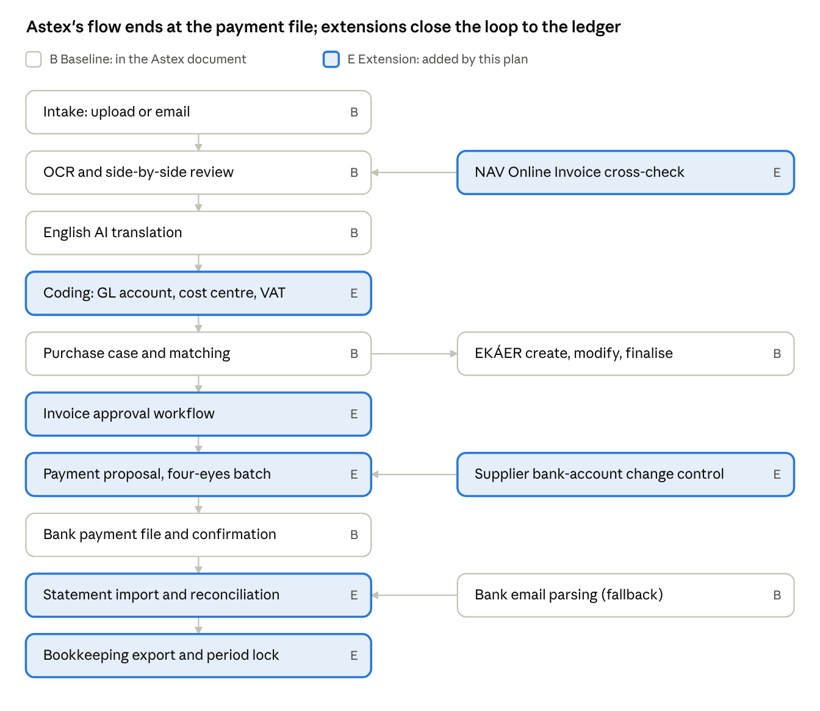
invoice-to-ledger flow · 10 main steps, 4 side steps
Five of the ten main steps are extensions. Astex's own flow stops at the payment file and leaves approval, reconciliation and the handover to the ledger undefined.

7.1 Baseline and refined (from the Astex document)
ID | Requirement | Tag | Acceptance criteria
FI-01 | Intake by manual upload and a dedicated email address: MIME parsing, sender, size and type checks, de-duplication by Message-ID and checksum, unsupported items sent to review | B p.5, 7 | The same email sent twice creates one invoice
FI-02 | Invoice OCR of the fields Astex lists: supplier, tax ID, number, issue, performance and due dates, reference, subject, currency, net, VAT, gross, item lines, source language | B p.5 | Field mapping confirmed on representative Astex invoices before OCR acceptance
FI-03 | Side-by-side review against the original, editable values, validation messages, confidence shown | B p.5 | Totals that do not add up block approval
FI-04 | English AI translation of subject, items, line descriptions and relevant text after review; original and translation stored and searchable | B p.5, 8 | Every approved invoice has a stored translation linked to its source text
FI-05 | Register views New/Review, Open, Incomplete, Closed with sort, filter, saved views | B p.5 | Each invoice appears in exactly one view
FI-06 | Purchase case linking invoice, delivery note, EKÁER declaration, closing document and other evidence; states New, Processing, Incomplete, Ready, Paid, Closed; one active case per file, reassignment audited | B p.6 | Required document roles configurable by purchase type
FI-07 | Explainable matching on reference numbers, supplier, dates, amount, weight and goods description; high auto-links, medium goes to ranked review, low stays unmatched; thresholds configurable | B p.6 | No auto-link on a single weak signal; each link stores its explanation
FI-08 | NAV Online Invoice query with a dedicated technical user: paging, retries, logging, test and production separated | B p.7 | Agreed NAV test scenarios run with no duplicates
FI-09 | EKÁER create, modify and finalise through the API once mandatory data is validated; request, response and time stored | B p.6 | Missing or rejected data stays in review
FI-10 | Payment preparation: select approved unpaid invoices, validate beneficiary, account and amount, generate the bank import file, confirm submission | B p.7 | Bank accepts the generated test file
FI-11 | Bank notification-email parsing and match proposal | B p.7 | Replaced as primary source by FI-28; kept as a fallback
FI-12 | Finance dashboard: monthly spend, paid on time, incomplete cases, review backlog, outstanding and overdue invoices, supplier history | B p.8 | Totals reconcile with the UAT dataset
FI-13 | Supplier master with tax ID first and controlled name aliases | R (B p.6) | Two spellings of one supplier resolve to one record
FI-14 | Goods synonym dictionary maintained by finance users | R (B p.6, 8) | A new synonym takes effect in search immediately

7.2 Extensions (not in the Astex document)
ID | Requirement | Priority | Why it will be needed
FI-20 | Full supplier master: EU VAT number, addresses, verified bank accounts, payment terms, default GL account and cost centre | Must | Payment and coding depend on it
FI-21 | Bank-account change control: dual approval, verification note, payments held for a set period after a change | Must | Changed bank details are the most common invoice-fraud route
FI-22 | Invoice types: credit note, corrective invoice, storno, advance invoice and its final settlement, pro forma (not posted) | Must | Hungarian invoice chains include these weekly
FI-23 | Duplicate-invoice detection: same supplier and number, or same amount and date | Must | Email and paper often deliver the same invoice twice
FI-24 | NAV-first capture: domestic invoice data pulled from NAV and compared with OCR; mismatches flagged; invoices in NAV but not received raise an alert | Must | Cuts OCR errors and catches invoices that never arrived
FI-25 | Approval workflow by amount, supplier and cost centre, with delegation, rejection reasons and reminders | Must | No company pays 100 invoices a day without approvals
FI-26 | Coding: GL account, cost centre, project or customer, VAT code; suggestions learned from the supplier's history | Must | Required for the bookkeeping export
FI-27 | Payment proposals by due date, partial payments, four-eyes batch approval, HUF domestic and SEPA formats | Must | Extends FI-10 to real payment practice
FI-28 | Bank statement import (CAMT.053, MT940 or CSV) with automatic matching to invoices and batches | Must | Reliable for every bank, with no bank API needed
FI-29 | Daily exchange rates stored; HUF equivalent per invoice on the date rule Astex's accountant sets | Must | Reports in HUF need it
FI-30 | Bookkeeping export in the accounting software's import format, linked to stored documents; exported records locked | Must | The accountant's ledger must receive the data
FI-31 | Period lock after export; changes after that need a reason and a corrective export | Should | Keeps the platform and the ledger consistent
FI-32 | Reports: AP ageing, due list, supplier balance, spend by cost centre, input-VAT summary for reconciliation, EKÁER status | Should | The manager and accountant will ask for these first
FI-33 | Accounting-document retention of at least 8 years, with a per-document flag for whether the paper original is kept | Must | Statutory; see section 11
FI-34 | Sales invoices, customer master and receivables | Could, confirm need | "Financial management" usually means both directions
FI-35 | Cash-flow forecast from payables, receivables and budget | Could | Logical once AP and AR are in one place
FI-36 | Employee expense claims and petty cash | Could | Commonly requested after go-live

8. Non-functional requirements
The Astex document names the right qualities (security, reliability, restore checks) but sets no numbers. These proposed targets fit the stated volumes with headroom for five years of data, and are confirmed in Stage 0.
Area | Target | Tag
Capacity | 2,500 invoices and 15,000 files a month; 5 years of history with no re-architecture | E
Screen speed | Lists and search return in under 2 seconds (95th percentile) with 150,000 invoices stored | E
OCR turnaround | Under 2 minutes per invoice (95th percentile) from receipt to review queue | E
Review productivity | A clean invoice can be confirmed in 60 seconds or less, keyboard only | E
Availability | 99.5% during Astex business hours; maintenance outside 07:00–19:00 Budapest time | E
Backup and recovery | Point-in-time recovery; data loss at most 15 minutes (RPO); service restored within 8 hours (RTO); restore tested every quarter | R (B p.10)
Security standard | OWASP ASVS level 2; external penetration test before first go-live | E
Encryption | TLS in transit; encryption at rest for database, files and backups | R
Data residency | Database, files, backups, OCR and AI processing inside the EU | R (B p.9, 10)
Accessibility | Onboarding form meets WCAG 2.1 AA | E
Devices | Admin: current Chrome, Edge, Firefox, Safari on desktop. Onboarding: iOS and Android phones | R (B p.3)
Languages | Admin UI in Hungarian and English; onboarding form in the languages Astex selects | E
Observability | Structured logs, metrics, alerts on OCR, translation, email, NAV, EKÁER, bank and notification failures; correlation ID per request | B p.10
Maintainability | Automated tests on parsers, matching and permissions; infrastructure as code; documented API | R (B p.11)
Exit and portability | Complete data and document export in open formats; source code and accounts owned by Astex | E

9. Integration specifications
The accounting-software export is the highest-risk integration: it is a Must, and today we do not know which software Astex's accountant uses. Every integration is built as a replaceable adapter with its own test environment, logging and retry rules (B p.7, 9).
Integration | Direction | Purpose | Tag | Method | Astex must provide | Risk
NAV Online Invoice (Online Számla) API | Inbound | Incoming invoice data; supplier tax-number check | B p.7 / E (cross-check, tax-number check) | REST/XML API with technical user | Technical user, signing and exchange keys, test access | Medium
NAV EKÁER | Outbound | Create, modify, finalise declarations | B p.6 | EKÁER API | EKÁER API access and credentials | Medium
Inbound email | Inbound | Invoices, related documents, bank notices | B p.7 | Dedicated address on Astex's domain, routed to the platform | DNS changes, sender allow-list | Low
Transactional email | Outbound | Invitations, reminders, digests | B p.3, 4 | Email service with SPF, DKIM, DMARC | Sending domain | Low
OCR provider | Outbound | Field extraction from scans | B p.4 | Provider adapter | Pays usage (B p.8) | Medium: accuracy and data protection
AI translation provider | Outbound | English translation of invoice content | B p.8 | Provider adapter | Pays usage (B p.8) | Medium: data protection
Bank payment file | Outbound file | Transfer batches | B p.7 | Bank's HUF domestic import format; SEPA pain.001 for EUR | Bank name, format specification, sample file | Medium
Bank statements | Inbound file | Payment reconciliation | E | CAMT.053, MT940 or CSV, upload or scheduled import | Statement samples | Low
Accounting software | Outbound file or API | Bookkeeping export | E | Import format of the chosen software | Software name, chart of accounts, accountant contact | High: unknown today
Payroll provider | Outbound file | Joiners, changes, leavers | E | Provider's import format | Provider name and format | Medium
Central bank exchange rates (MNB) | Inbound | Daily rates for HUF equivalents | E | Public MNB rate service | Rate-date rule from accountant | Low
EU VIES | Inbound | Validate EU suppliers' VAT numbers | E | Public VIES service | None | Low
SMS or WhatsApp gateway | Outbound | Worker reminders | E (Could) | Messaging provider adapter | Provider account, consent wording | Low
Direct bank API | Both | Automated payments and statements | B p.11 (optional) | Bank-specific; separate discovery | Bank agreement | High
Rules that apply to every integration:
- Server-side credentials. Secrets are held server-side only, with separate test and production credentials (B p.9).
- Full logging. Every request and response is logged with a correlation ID, and personal data is masked in the logs.
- No duplicates on retry. Retries are idempotent, and a failed job has an owner and a recovery action (B p.10).
- Contract tests. Each adapter has contract tests against the provider's sandbox, or against recorded samples where no sandbox exists.

10. Data model, master data and migration
The Astex entity list (B p.9) is kept and extended. Extension entities are created in the first release even where their screens come later, because adding them afterwards would mean migrating live financial data.

Entities
Area | From the Astex document (B p.9) | Added by this plan (E)
Shared | Organisations, users, memberships, roles, files, file versions, OCR jobs, extracted fields, notifications, audit events | Legal entities, cost centres, document links (any file to any record), workflow definitions, workflow instances, tasks, custom-field definitions, retention policies
HR | People, employee profiles, invitations, submissions, form schemas, answers, document requirements, person documents, expiries, templates, generated files | Employment records (effective-dated), customer assignments, offboarding cases, training and medical records, permit renewal cases, payroll exports
Finance | Suppliers, aliases, purchase cases, invoices, invoice lines, finance documents, matches, payment events, NAV runs, inbound emails | Supplier bank accounts and change requests, invoice relations (credit note, correction, advance), approvals, GL accounts, VAT codes, coding lines, payment batches and allocations, bank statements and lines, exchange rates, accounting exports, accounting periods; later customers and sales invoices

Modelling rules
- Effective dating. Employment, assignment and supplier bank data keep their history instead of being overwritten.
- Money. Every amount is stored with its currency, HUF equivalent, rate and rate date. Floating-point numbers are never used.
- Mandatory dimensions. Legal entity and cost centre exist on every financial row from day one, even while Astex uses only one of each.
- No silent deletion. Records are retired, reversed or anonymised under retention rules (B p.6). Documents link through one generic link table, so new record types need no new file tables.

Migration plan — R (B p.8 states the goal, not the method)
- Inventory. List every source: Excel invoice registers, HR spreadsheets, scan folders, mailboxes, calendar reminders. Record row counts, years covered and owners.
- Cut-off decision. Proposed: all open invoices and cases, the current and previous financial year, every active and recently departed employee. Older material is imported as a searchable archive without OCR review.
- Mapping and clean-up. We provide mapping templates and validation reports; Astex cleans source data (B p.8).
- Two trial loads. Each produces a reconciliation report of counts and totals per register, signed by the module owner.
- Cutover and parallel run. Final load, then 4 weeks of finance running in parallel with Excel before Excel stops being the record.

11. Compliance: GDPR, Hungarian accounting and employment rules
The platform supports compliance, but Astex owns the legal decisions (B p.10). Each item below names a design consequence; Astex's counsel and accountant confirm the rules during Stage 0.
Obligation | What the platform must do | Tag | Astex owner
GDPR lawful basis, privacy notices, records of processing | Log notice version acknowledged at onboarding; keep a processing inventory per data category | B p.3, 10 | Legal or DPO
GDPR DPIA for identity and workforce documents | Supply technical input: data flows, subprocessors, controls | B p.10 (recommended) / R (make it a Stage 0 deliverable) | Legal or DPO
Processor and subprocessor agreements | Every OCR, AI, email, hosting and messaging provider listed, EU processing confirmed, DPA signed before production | B p.10 / R | Legal
Data minimisation | Collect each field only where the requirement matrix makes it necessary (for example mother's name, bank account) | R | HR owner, legal
Data-subject rights | Export and correct a person's data; deletion subject to statutory retention | B p.10 / E (tooling) | Legal
Accounting-document retention | Keep invoices and related accounting documents for at least 8 years, readable and unaltered | E | Accountant
Paper originals | If paper is to be discarded, scanning must meet Hungarian rules for authentic electronic copies; otherwise paper is kept and the platform records where | E | Accountant, legal
NAV invoice data | Treat NAV data as a cross-check, not a replacement for the source invoice | B p.7 | Finance owner
EKÁER | Declarations created, modified and finalised on time, with full request and response history | B p.6 | Finance owner
Third-country worker permits | Track permit validity, renewal cases and employer notification duties | B p.3–4 / E (renewals, notifications) | HR owner, immigration adviser
Temporary-work agency duties (if applicable) | Keep assignment records per worker and customer | E | HR owner, legal
EU AI Act | Keep AI to extraction and translation; no automated decisions about hiring or employment; humans confirm every AI-derived value | E | Legal
The last row matters most for the design. AI systems that make or support decisions about recruitment or employment fall into the EU AI Act's high-risk category. Keeping OCR and translation strictly assistive, with human confirmation, keeps the platform out of it.

12. Architecture options and design-for-change principles
The technology stack is open: the Supabase and Cloudflare design in the Astex document was suggested by the AI tool that drafted it, not mandated by Astex. We recommend a modular monolith on managed PostgreSQL in an EU region, with the final hosting choice made by a one-week technical spike in Stage 0.
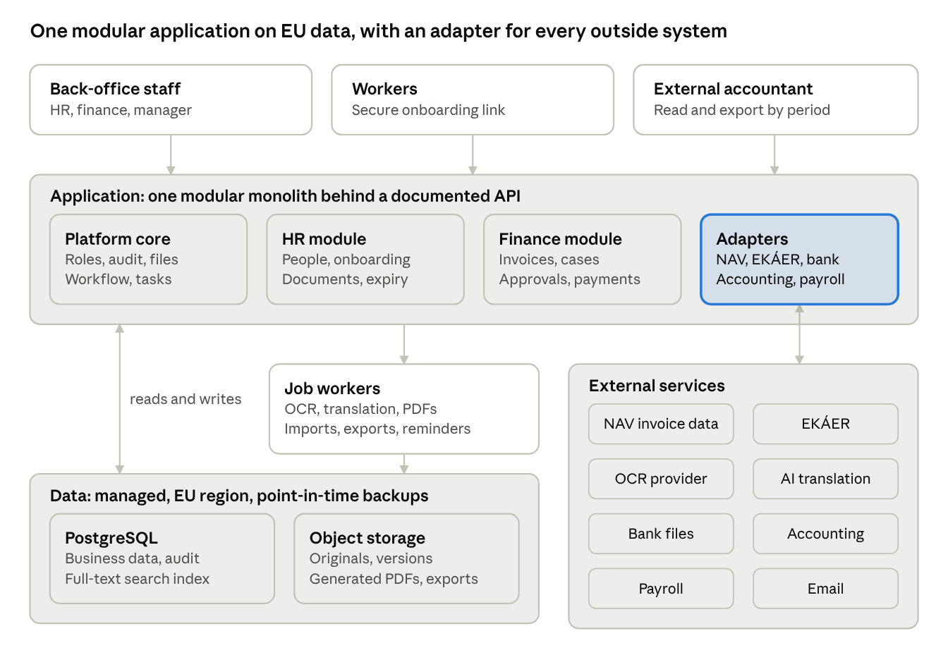
target architecture · 4 modules, job workers, EU data, 8 external services
Business rules live in one application. Every outside system is reached through its own adapter, so a new bank, accounting package or OCR provider is an addition, not a rewrite.

Options
Option | Description | Strengths | Weaknesses | Verdict
A. Astex proposal | React SPA and Hono API on Cloudflare Workers; Supabase Postgres, Auth and Storage; Cloudflare Queues | Low operations effort; fast start; EU database region | Workers runtime limits for long OCR, PDF and XML jobs; business rules split between API and row-level security; edge processing location needs a residency check; tied to two vendors | Viable if the spike shows the runtime limits are manageable
B. Conventional backend | React SPA; containerised API and job workers (Node.js/TypeScript or similar); managed PostgreSQL, object storage and queue in an EU cloud region | No runtime limits; mature libraries for XML, SEPA, PDF; one place for business rules; easy to hire for | Slightly more operations work | Recommended; Supabase can still serve as the managed PostgreSQL
C. ERP base (for example Odoo) | Configure an existing ERP and build Astex-specific modules | Accounting, approvals and HR basics exist already | Hungarian NAV and EKÁER need custom modules; heavy customisation fights the framework; licence costs | Evaluate briefly, since much of the Extension scope is standard ERP

Design-for-change principles
These rules are what let late requirements land as additions rather than rewrites.
- Modular monolith. Platform, HR, Finance and Integrations are separate modules with explicit interfaces, in one deployable application.
- Configuration over code. Document types, requirement matrix, thresholds, reminder windows, templates and approval rules are data, edited in admin screens.
- One workflow engine. Invoice approval, onboarding review, offboarding and change requests all run on it, even when release 1 uses single-step flows.
- One document model. Every file links to any record through a generic link, so new record types need no new storage design.
- Domain events and an outbox. Audit, notifications, search indexing and integrations react to recorded events, so new consumers can be added without touching the core.
- Adapters for every outside system. OCR, AI, bank formats, accounting and payroll exports can be swapped or added per provider.
- Dimensions and history from day one. Legal entity, cost centre, currency and effective dates exist in the schema before they appear on screen.
- API first. The web app uses the same documented API that a future self-service portal or mobile app would use.
- Custom fields with validation. Client-specific extra fields need no schema migration.

13. Delivery roadmap, deliverables and milestones
Five committed phases take about 10–12 months, following Astex's order of finance first, then HR (B p.11). Each phase ends at a gate that Astex signs before the next phase's price becomes binding. Durations are estimates for a team of one project manager and analyst, one tech lead, two full-stack developers, a part-time QA engineer and a part-time UX designer. They are re-estimated at gate G0.
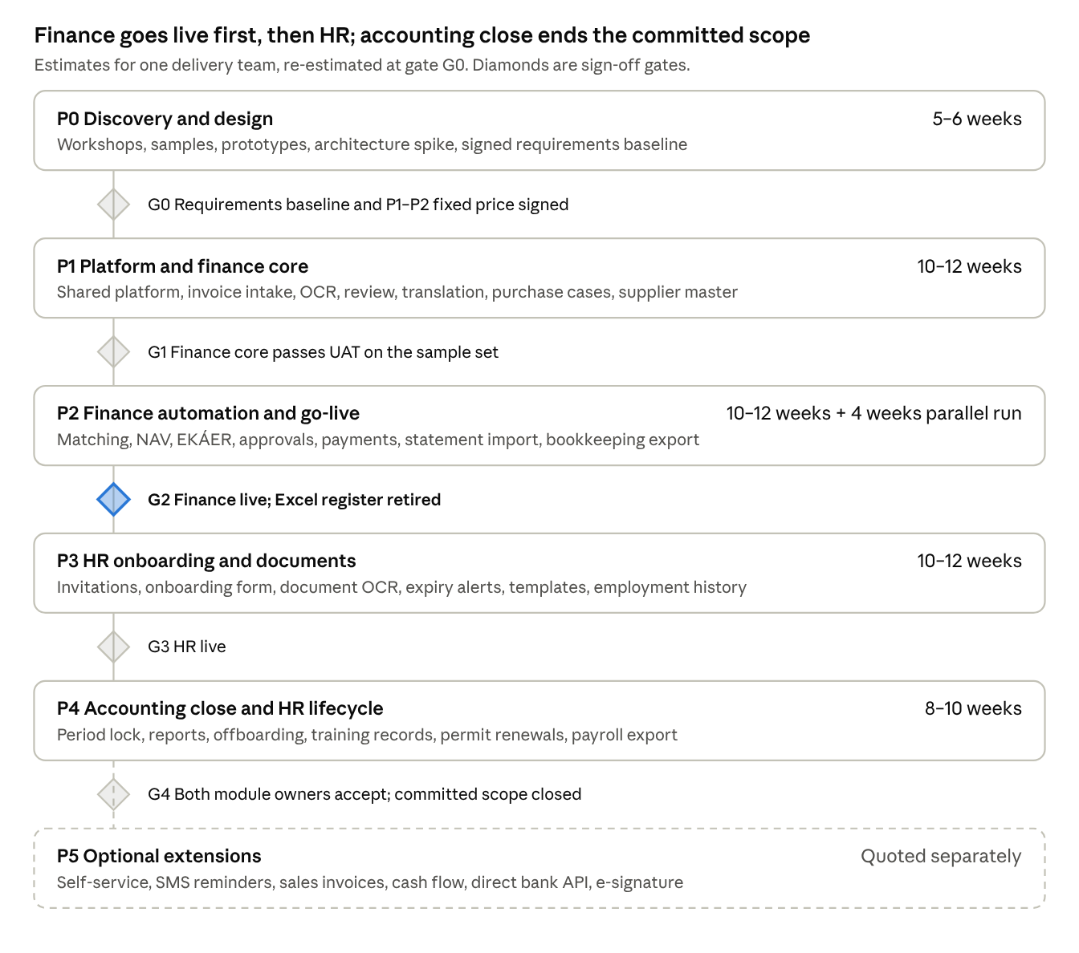
delivery roadmap · 6 phases, 5 gates
Gate G2 is the main business milestone: from then on the platform, not Excel, is the finance record of truth.
Phase | Estimate | Main deliverables | Exit gate
P0 Discovery and design | 5–6 weeks | Workshops with every user group; as-is and to-be process maps; labelled sample set (at least 300 invoices and 100 HR documents); signed requirements baseline; clickable prototype of the invoice review and onboarding screens; architecture decision from the spike; migration inventory; DPIA input; NAV, EKÁER and bank access requested | G0 Requirements baseline and fixed price for P1–P2 signed
P1 Platform and finance core | 10–12 weeks | Shared platform (sign-in, roles, audit, file store, jobs, workflow engine, task inbox, admin settings); invoice intake, OCR, review, translation, register; purchase cases; supplier master; invoice types; duplicate detection; coding fields; first migration trial | G1 Finance core passes UAT on the sample set
P2 Finance automation and go-live | 10–12 weeks, then 4 weeks parallel run | Matching engine; NAV query and cross-check; EKÁER; approvals; bank-account change control; payment proposals and files; statement import; exchange rates; bookkeeping export; finance dashboard and search; final migration | G2 Finance live; Excel register retired after the parallel run
P3 HR onboarding and documents | 10–12 weeks | Person records, invitations, onboarding form, document OCR, requirement matrix, expiry alerts, HR dashboard, template library and PDF generation, employment history, customer assignments if confirmed, HR migration | G3 HR live
P4 Accounting close and HR lifecycle | 8–10 weeks | Period lock, AP reports, scheduled reports; offboarding, medical and training records, permit renewal cases, payroll export, statutory registration tracking, workforce reports | G4 Accepted by both module owners; project closed
P5 Optional extensions | Quoted separately | Self-service portal, SMS or WhatsApp reminders, accommodation, e-signature, sales invoices and receivables, cash-flow forecast, direct bank API, semantic AI search | Per change request
Each go-live is followed by 4 weeks of hypercare. P3 can start during P2's parallel run, which saves about 4 weeks. With a second team, HR could run alongside finance from P1, at a higher monthly cost.

14. Testing and acceptance
A phase is accepted when every requirement in it meets its acceptance criterion from sections 5–7 on the agreed UAT dataset, with no open Critical or High defects. The Astex document's test layers and acceptance outcomes (B p.11) are kept, and the items marked E are added.

Test layers
Layer | Scope | Tag
Unit tests | Parsers, normalisation, matching scores, validation rules | B p.11
Database and integration tests | Constraints, idempotency, adapter contracts against sandboxes | B p.11
Permission tests | Allow and deny for every role, entity and masked field | B p.11
End-to-end browser tests | Main workflows per module | B p.11
Resilience tests | Retry, dead-letter, restore from backup | B p.11
Performance tests | The section 8 targets on a dataset of 5 years' volume | E
Security test | External penetration test before the first go-live | E
Migration reconciliation | Counts and totals per register signed per trial load | E
OCR accuracy measurement | Field-level precision on a labelled sample, by supplier group and document type | R (B p.11)

OCR accuracy method — R
The Astex document rightly refuses to promise an accuracy figure without data (B p.11). We make that concrete:
- A labelled sample of at least 300 invoices covers the top 30 suppliers and every language and layout Astex receives.
- Accuracy is measured per field (supplier tax ID, invoice number, dates, net, VAT, gross).
- Targets are set at G0 from the measured baseline of the chosen provider.
- Fields below target always go to human review, so accuracy affects speed, not correctness.

UAT protocol — B p.11, R
- Owners and samples. One Astex owner per module supplies anonymised or redacted samples.
- Response time. Astex responds within 5 business days per milestone (B p.11). Late responses move the plan by the same number of days.
- Defect versus change. A defect is a failure against a signed acceptance criterion. Anything else is a change request (section 16).
- Severity. Critical: blocks a business process, no workaround. High: workaround exists but is costly. Medium: inconvenience. Low: cosmetic.
- Sign-off. Each gate has a written sign-off listing accepted requirements and any deferred Low defects.

15. Risks, assumptions and dependencies
The top risk in projects of this kind is requirements that only surface once users see the system. The plan answers it three ways: discovery with real users and prototypes, an architecture built for the Extension scope, and strict change control.

Risk register
Risk | Likelihood | Impact | Mitigation
Unstated requirements appear mid-project | High | High | Stage 0 walkthroughs with every user, clickable prototypes, the Extension register in this plan, design-for-change principles, change control
Accounting software import format unknown or restrictive | High | High | Identify the software and its import spec in week 1 of Stage 0; build the export early in P2
NAV, EKÁER or bank access arrives late | Medium | High | Request access at the start of Stage 0; build against sandboxes and recorded samples
Users relabel changes as defects in UAT | High | Medium | Signed acceptance criteria; written defect definition; change request log reviewed weekly
OCR accuracy low on poor scans or unusual layouts | Medium | Medium | Labelled sample early; NAV-first capture for domestic invoices; fast review screen
Excel and folder data too inconsistent to migrate | Medium | Medium | Cut-off rule; Astex owns clean-up; two trial loads with reconciliation
Identity documents sent to non-EU OCR or AI providers | Medium | High | Only providers with EU processing and a signed DPA; DPIA before production
Astex reviewers unavailable for UAT | Medium | Medium | Named owners and deputies; 5-day response rule with plan impact
Rule changes at NAV or EKÁER, or in immigration law | Medium | Medium | Isolated adapters; maintenance contract covers regulatory updates
OCR and AI usage costs exceed expectations | Low | Medium | Monthly cost estimate at G0; usage caps and alerts
Runtime limits if option A is chosen | Medium | Medium | Architecture spike in Stage 0 before committing

Assumptions
- One Astex organisation; additional legal entities, if any, are known by G0.
- Astex's accounting software, payroll provider and bank are named in Stage 0 and support file import or export.
- Astex pays all hosting, OCR, AI, messaging and third-party subscription costs directly, with accounts in its own name (B p.8 for AI costs).
- Contract and document templates are supplied legally approved by Astex (B p.4).
- Physical signatures stay outside the platform unless e-signature is accepted (B p.4).

Dependencies on Astex
- ☐ Name the HR owner, finance owner and sponsor
- ☐ Supply representative anonymised samples of invoices, related documents and HR documents
- ☐ Request the NAV Online Invoice technical user and EKÁER API access
- ☐ Provide bank payment-file and statement format specifications with samples
- ☐ Introduce the external accountant and the payroll provider
- ☐ Provide the legal review of the privacy notice, DPIA, retention rules and templates
- ☐ Make DNS and mailbox changes for the intake address

16. Commercial framework, change control and support
The commercial pages of the Astex document (pages 12–13) were not received, so this whole section is E. We propose a paid fixed-fee discovery, then a fixed price per phase against the signed baseline. Change requests are priced at an agreed day rate. Amounts are set after G0.

Pricing structure
Item | Model | When priced
P0 Discovery and design | Fixed fee | Now
P1 and P2 Finance | Fixed price per phase | At G0
P3 HR | Fixed price | At G0 or G2
P4 Accounting close and HR lifecycle | Fixed price | At G2
Accepted Extension items | Fixed price per item | When Astex accepts each item
Change requests | Day rate, estimated before work starts | Per request
Hosting, OCR, AI, messaging | Paid by Astex directly to providers | Monthly estimate at G0
Support and maintenance | Monthly fee per service level | Before first go-live
Payment milestones follow the gates: part on phase start, the rest on gate sign-off.

Change control
- Anyone raises a change request: what, why, priority.
- We return an impact assessment within 5 business days: scope, cost, schedule, risk, and affected requirements.
- The Astex sponsor approves or rejects it in writing.
- Approved changes update the requirements baseline and the plan, with a new version number.
Small changes under 1 day each can be batched and settled monthly, by agreement.

Ownership and exit
- Ownership. Astex owns the source code, data, documentation and all cloud and provider accounts.
- Ongoing access. Astex has continuous access to the code repository; deployment is scripted, so another supplier could take over.
- Data export. A full export of data and documents in open formats is available on request.

Warranty, hypercare and support
- Warranty. 3 months per phase after go-live: defects against signed acceptance criteria are fixed at no charge.
- Hypercare. 4 weeks after each go-live, with daily check-ins and priority fixes.
- Training. Administrator and user training per module, with short user guides in Hungarian and English.
Proposed support service levels (business hours):
Severity | First response | Target fix or workaround
Critical | 2 hours | 1 business day
High | 4 hours | 3 business days
Medium | 1 business day | Next release
Low | 3 business days | Planned release

17. Open questions for Astex (discovery questionnaire)
These questions close the gaps found in the Astex document and decide which Extensions become committed scope. They are ordered by their effect on the price and the design. Each answer is recorded against the related requirement ID.

Business and organisation
- ☐ Does Astex place workers at customer sites as a temporary-work agency? (HR-21)
- ☐ How many legal entities employ staff or receive invoices? (SH-01)
- ☐ How many HR users will there be, and who approves onboarding?
- ☐ How many new hires and leavers are there per month, and in which seasons?
- ☐ Which languages do the workers read, and which must the onboarding form support? (SH-17)
- ☐ Which business KPIs from section 2 matter most to management?

Finance
- ☐ Which accounting software does the accountant use, and is bookkeeping in-house or outsourced? (FI-30)
- ☐ Who approves invoices today, and are there amount limits? (FI-25)
- ☐ Is there a chart of accounts and cost-centre list to code against? (FI-26)
- ☐ Which banks and currencies are used, and can statements be exported? (FI-27, FI-28)
- ☐ How often do credit notes, corrections and advance invoices occur? (FI-22)
- ☐ What share of invoices are from foreign suppliers or in foreign languages? (FI-04, FI-24)
- ☐ Are paper originals kept, or should they be discarded after scanning? (FI-33)
- ☐ Does Astex issue sales invoices, and with which tool? (FI-34)
- ☐ Which purchase types need which documents in a purchase case? (FI-06)
- ☐ Which reports does the manager use today? (FI-32)

HR
- ☐ Which payroll provider or system is used? (HR-27)
- ☐ Which documents beyond the Astex list must be tracked: medical fitness, training, licences? (HR-24)
- ☐ How are permit renewals handled today, and by whom? (HR-25)
- ☐ How many contract and letter templates are in use? (HR-26)
- ☐ What happens when someone leaves: steps, owners, documents? (HR-22)
- ☐ Is worker accommodation provided and tracked? (HR-31)

Data, compliance and technical
- ☐ How many years of Excel and scanned history should be migrated? (section 10)
- ☐ Has Astex appointed a DPO, and who signs the DPIA? (section 11)
- ☐ Are there existing company accounts (Microsoft 365, Google Workspace) to use for sign-in?
- ☐ Is there a preferred cloud provider or an existing IT supplier to coordinate with?
- ☐ What budget range and target go-live date does Astex have in mind?

